SpendWise
A Simple Backend Learning Project
Ideation Phase · Empathize & Discover · Empathy Map Canvas

Date | 08 March 2026
Project Name | SpendWise
Document Type | Ideation Phase — Empathize & Discover
Team ID | SWTID-2026-1005

Overview
An empathy map is a structured tool for understanding a user's thoughts, feelings, and actions while engaging with a product or learning experience. For SpendWise, it focuses on the mindset of a beginner backend student navigating Node.js, Express, MongoDB, and JWT authentication. By mapping out what the user thinks, sees, hears, says, does, fears, and gains, the team can ensure the solution remains simple, focused, and genuinely useful.
Why Empathy Mapping Matters
Shifts design focus from assumptions to real user needs and emotions.
Surfaces hidden frustrations and blockers that are not always stated directly.
Keeps the entire team aligned around the same user perspective throughout development.
Ensures SpendWise stays beginner-friendly rather than feature-heavy.

1 | User Persona  The central character whose perspective drives the entire empathy map.

Persona Attribute | Detail
Name / Role | Student / Beginner Backend Developer
Background | College student or self-learner exploring Node.js backend for the first time
Primary Goal | Build a simple, complete backend project using CRUD, JWT, and MongoDB
Tech Context | Node.js, Express.js, MongoDB, Mongoose, JWT, Postman
Submission Need | Needs a working project for academic submission, portfolio, or viva

2 | Empathy Map Canvas — All Six Quadrants  A complete view of the user's inner world, environment, actions, and emotions.

Quadrant | Observations & Insights
THINK & FEEL | • Wants to learn backend development in a practical, hands-on way  • Feels confused about how JWT, APIs, and MongoDB work together  • Worries about building a complete project for academic submission  • Aspires to become confident and articulate about backend concepts  • Cares deeply about truly understanding CRUD operations
SEE | • Sees many complex projects online that are difficult to understand  • Sees tutorials packed with code but lacking clear explanation  • Sees classmates building backend projects for college assignments  • Sees a clear gap — no simple, working backend example for beginners  • Sees Postman, MongoDB, and Node.js being used heavily in industry
HEAR | • Teachers say: "You must know CRUD and authentication"  • Friends say: "Make a simple project for submission"  • Seniors say: "Learn JWT and MongoDB — it's important for jobs"  • Online videos say: "Backend needs practice, not just theory"  • Peers regularly talk about pushing projects to GitHub
SAY & DO | • "I want a simple project to understand how backend really works"  • "JWT is confusing — I desperately need a clear working example"  • Builds small REST APIs and tests each endpoint in Postman  • Repeatedly tries to connect MongoDB and debug connection errors  • Pushes project code to GitHub for portfolio and peer review
PAIN | • Gets overwhelmed and confused by large, feature-heavy projects  • Struggles to wire JWT authentication to MongoDB and the API layer  • Keeps encountering errors in MongoDB connection and JWT token flow  • Lives with a constant fear of not grasping backend concepts properly
GAIN | • Wants a single, clean backend project that actually works end-to-end  • Needs solid understanding of CRUD + JWT + MongoDB in one place  • Success = All API endpoints tested and passing in Postman  • Success = Able to explain the project confidently in a viva or interview  • Success = Project live on GitHub, running correctly, portfolio-ready

Key Takeaway from the Canvas
The user does not need more features — they need a project that is simple enough to understand fully.
SpendWise directly addresses every pain point: focused scope, clear folder structure, step-by-step JWT flow.

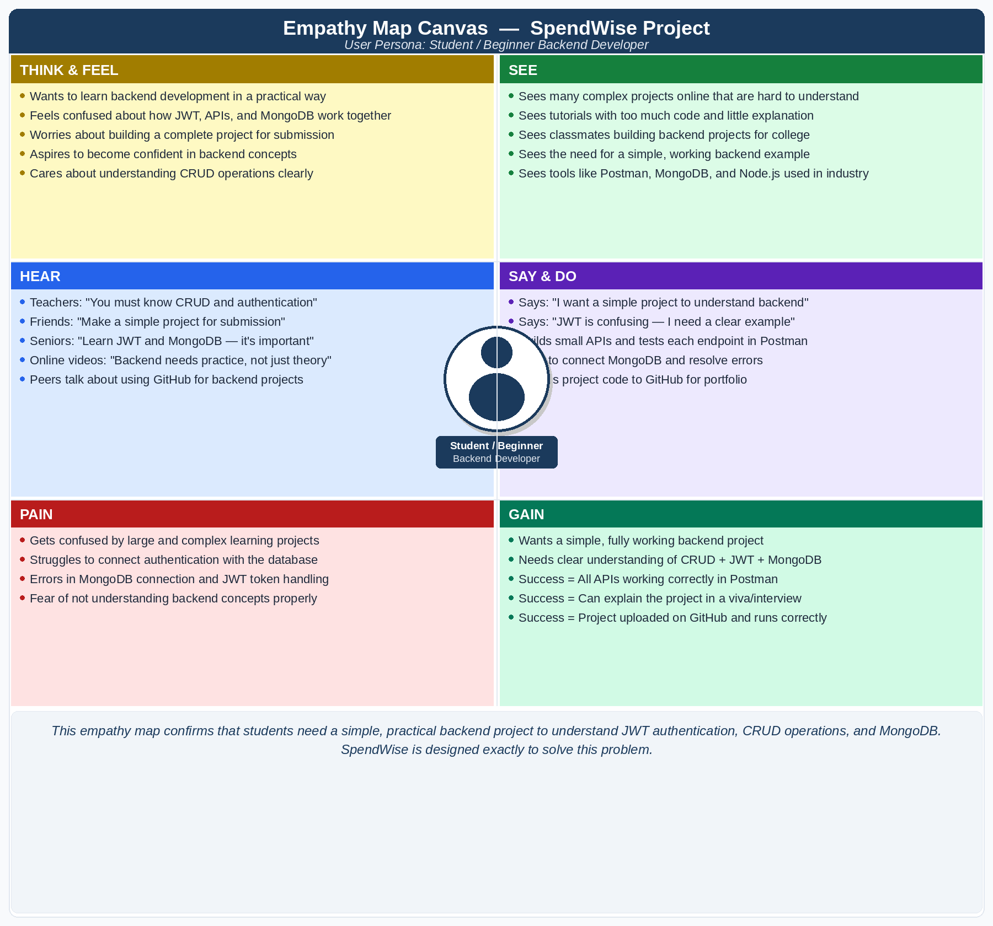

3 | Says, See, Does & Feels  A focused view of observable behaviour and expressed emotions.

Dimension | User Evidence
SAYS | • "I want a simple project to learn backend development"  • "I understand the theory, but actually coding it is very different"  • "JWT is confusing — I need a clear, complete working example"  • "I just want to register, log in, and manage data without complexity"
SEE | • Wonders how APIs, JWT, and MongoDB connect and interact together  • Observes that this project must not become overly complex  • Realises more hands-on practice is needed before facing interviews  • Hopes to recall and explain the entire flow clearly in a viva setting
DOES | • Searches online for simple Node.js + MongoDB starter projects  • Watches tutorial videos and actively tries to replicate them  • Tests each API endpoint using Postman or Thunder Client  • Pushes working code to GitHub for both practice and portfolio
FEELS | • Confused and overwhelmed when projects contain too much code  • Relieved and happy when a small API endpoint works as expected  • Frustrated and stuck when JWT tokens return unexpected errors  • Confident and motivated when able to explain the backend in a viva

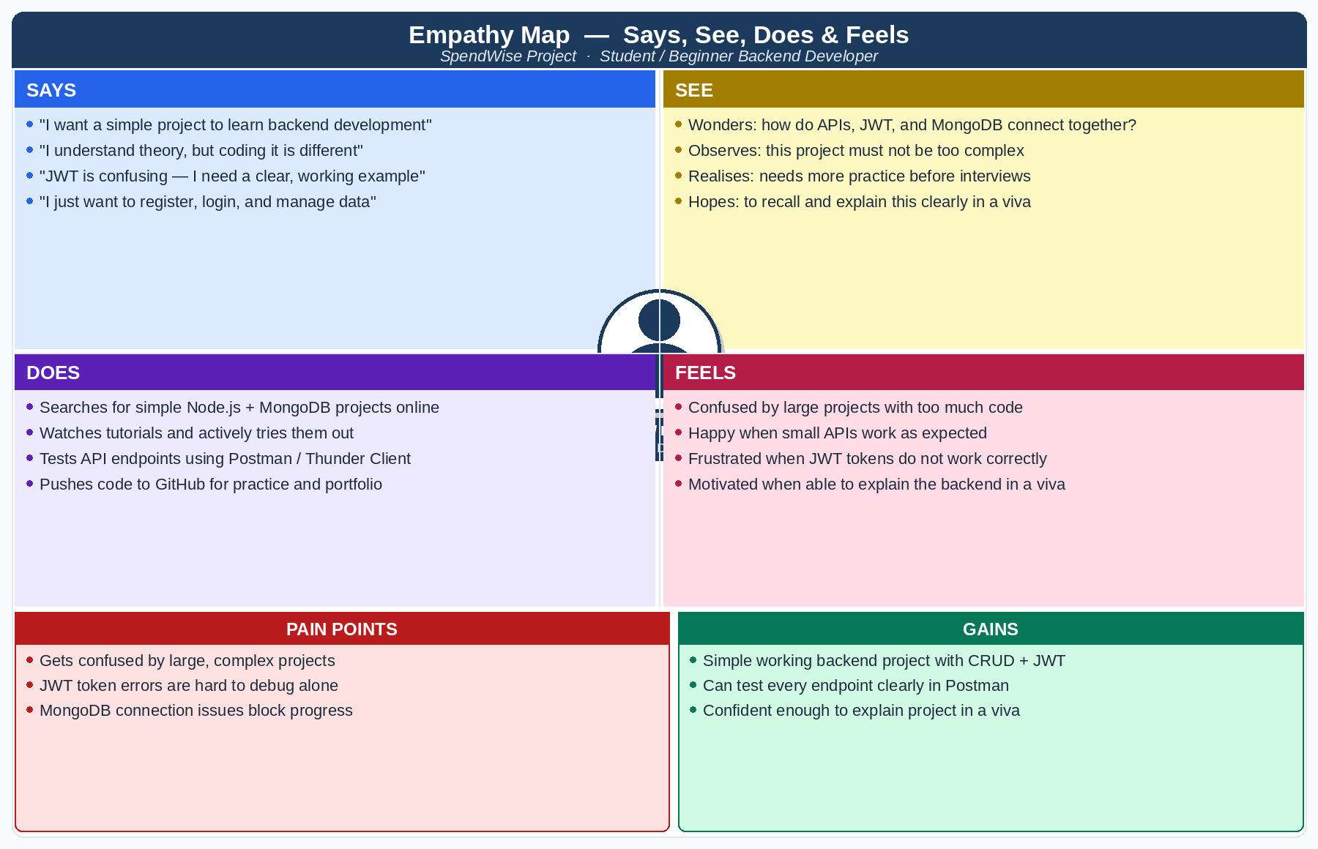

4 | Pain Points & Gains  What blocks the user and what success looks like for them.

Pain Points | Gains / Success Criteria
• Gets confused by large, complex learning projects  • Struggles to connect JWT authentication with the database  • Errors in MongoDB connection and JWT token handling  • Fear of not truly understanding backend concepts | • A simple, fully working backend project  • Clear grasp of CRUD + JWT + MongoDB in one project  • All API endpoints tested and passing in Postman  • Can explain the project confidently in a viva/interview  • Project uploaded to GitHub and running correctly

5 | How SpendWise Responds to the Empathy Map  Mapping every user pain point to a concrete design decision in the project.

User Pain Point | Root Cause | SpendWise Design Response
Complex projects cause confusion | Too many features bundled together | Minimal scope: only CRUD + JWT + MongoDB
JWT flow is unclear | No end-to-end auth example available | Step-by-step: Register → Login → Token → Protected Route
MongoDB connection errors block progress | Incorrect setup guidance in tutorials | Clean Mongoose connection with error handling shown
Folder structure is hard to follow | Projects mix logic without separation | Clear separation: routes / controllers / models
Cannot test endpoints easily | No ready-made test collection provided | Full Postman collection included for every endpoint
Hard to explain in viva | Project is too large to describe clearly | Focused scope means the student can walk through the entire project

Conclusion
The empathy map confirms that SpendWise is solving the right problem in the right way.
Beginner backend students do not need more content — they need clarity, structure, and a project small enough to fully own.
Every feature decision in SpendWise is a direct response to a pain point identified in this empathy exercise.

